**Baseline loss Rate**

UI Design Document

By: Saad Shahid

Dated: 15 January 2019

Table of Contents

Overview 4

Approach 4

System Flow 4

• Evolv UI Menu option 4

• Baseline loss Rate overview 5

• Baseline loss Rate Segment Setup 5

i. Segment List 5

ii. Add New Segments 6

iii. Activate/Deactivate Segment 7

iv. Delete segments 7

v. Edit segments 8

vi. View Segment 8

• Baseline loss Rate Scenario Setup 9

i. Scenario List 9

ii. Add Scenario 10

iii. Edit Scenario 11

iv. Delete Scenario 12

v. Lock/Unlock Scenario 12

vi. View Active Scenario 12

vii. Save Active Scenario 13

viii. Execute Active Scenario 13

ix. Error Scenario 14

x. Complete Scenario 14

Baseline loss Rate Scenario Result 15

i. OpenPool Methodology 15

ii. Migration Methodology 15

iii. Vintage Methodology 16

iv. Download vintage balance 16

v. Download loss rate 16

vi. Lock/Unlock Scenario 16

Baseline Loss Rate end-point details 16

# Overview

The user interface for Base Rate is designed as the primary interface between user and base rate calculator. User would be able to perform following activities :

1. Define segmentation criteria with associated lookback and other periods, execution methodology.
2. Setup scenarios with existing and/or new segments, lookback and other periods, Baseline methodology.
3. View results (loss factors) at segment level for screnarios.
   1. View intermediate results at above level.
4. Edit system generated Loss Factors ( only final results not internediate results) directly in user interface
5. Download system generated or user edited loss factors from user interface in a specified format.
6. Submit system generated or user edited loss factors as assumption for use in Allowance model.

# Approach

EVOLV UI component will be use which has also been used in EA project. Separate repository has been setup which contain all the UI components. Those UI component such as card-tree component, criteria builder component etc are used in base rate UI.

# System Flow

Reserving client with permission Baseline Lost Rate will able to see new menu option under valuation. Screenshot is shown as following.

# Evolv UI Menu option

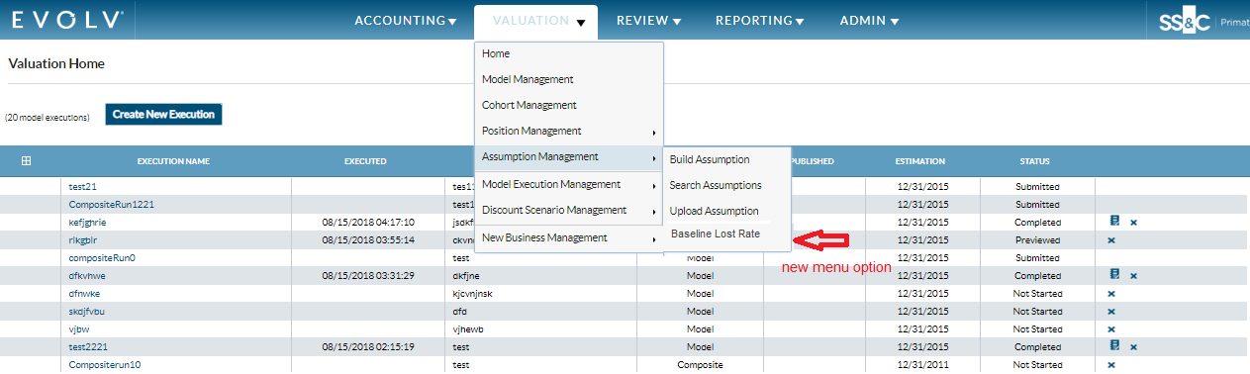

On clicking menu option, user will be authenticated and authorized and landed into base rate UI. Base rate landing page is configurable through property **reserving.baselinelossrate.url.**

# Baseline loss Rate overview

On selection of baseline lost rate menu option, new window will open with following page display on screen.

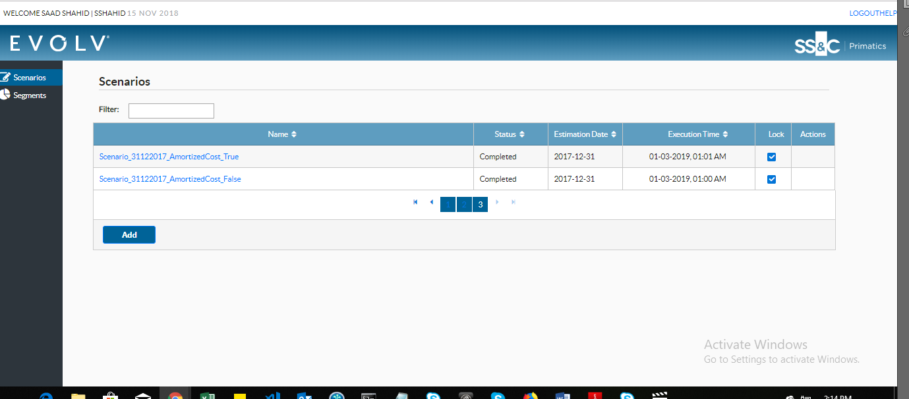

# Baseline loss Rate Segment Setup

## Segment List

On selecting segment from menu option, user will be redirected to following screen.

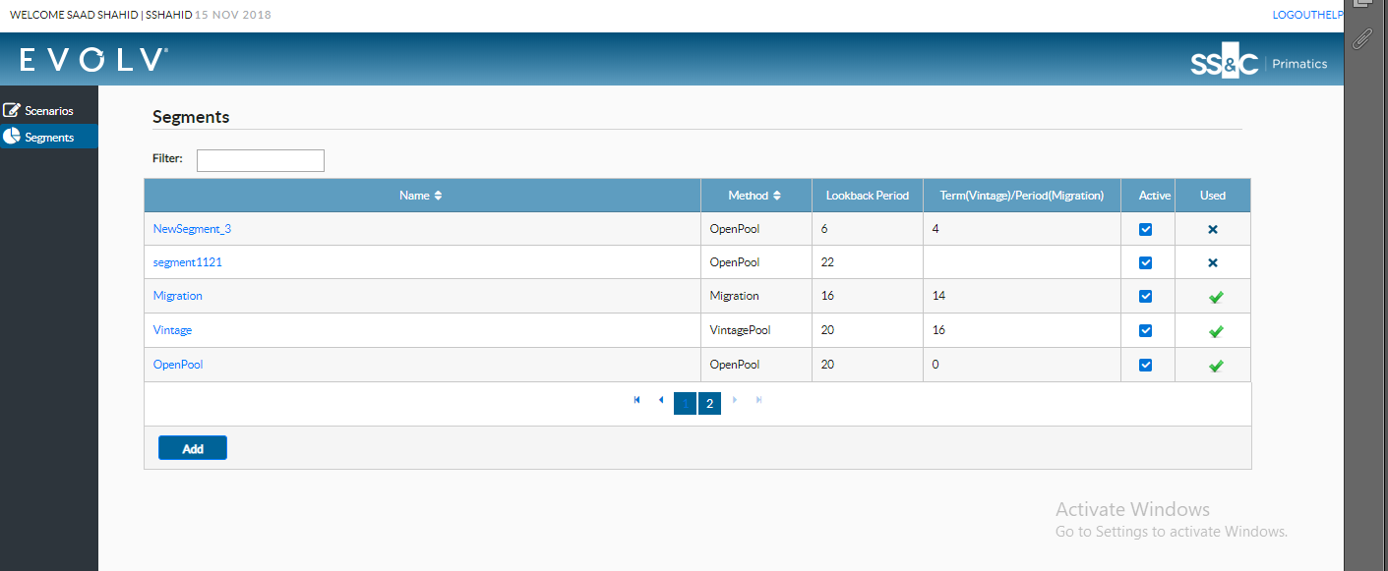

## Add New Segments

User can add new segment by pressing add button from segment list screen. Following screen is shown on screen.

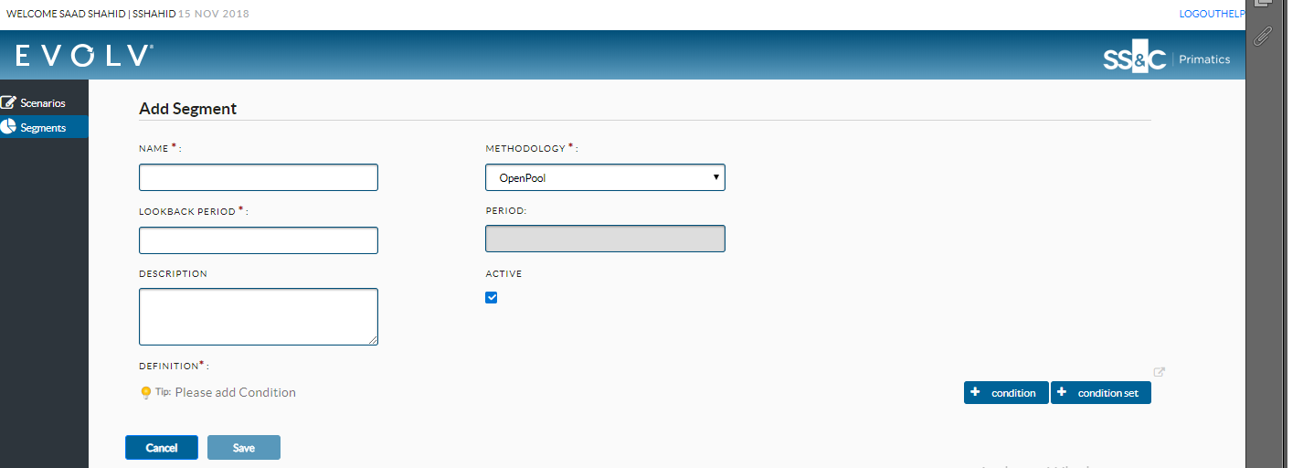

User can add different criteria from the screen. After adding all the mandatory fields from the screen, save button on the screen gets enabled. Screenshot is attached.

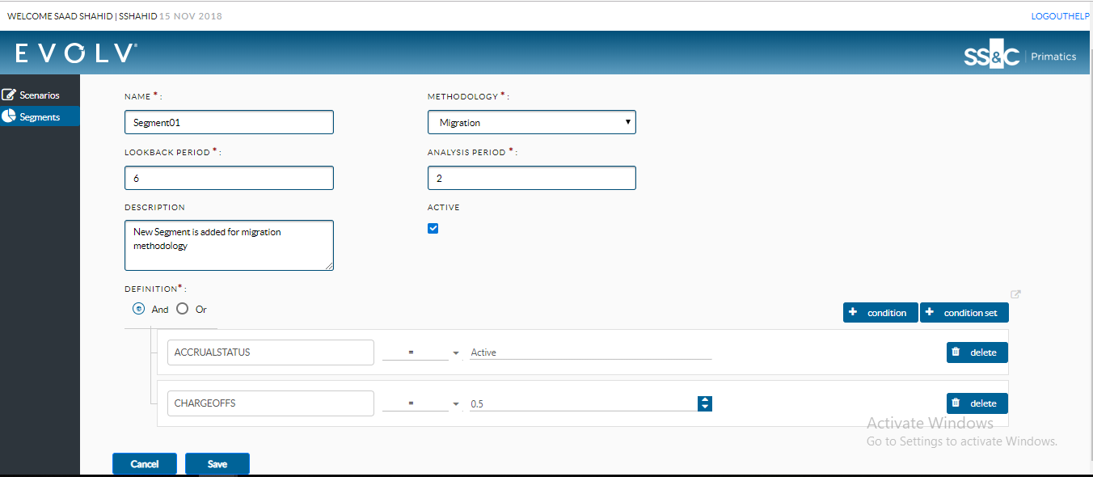

On saving the record. User will able to see the record on the segment list view as shown below.

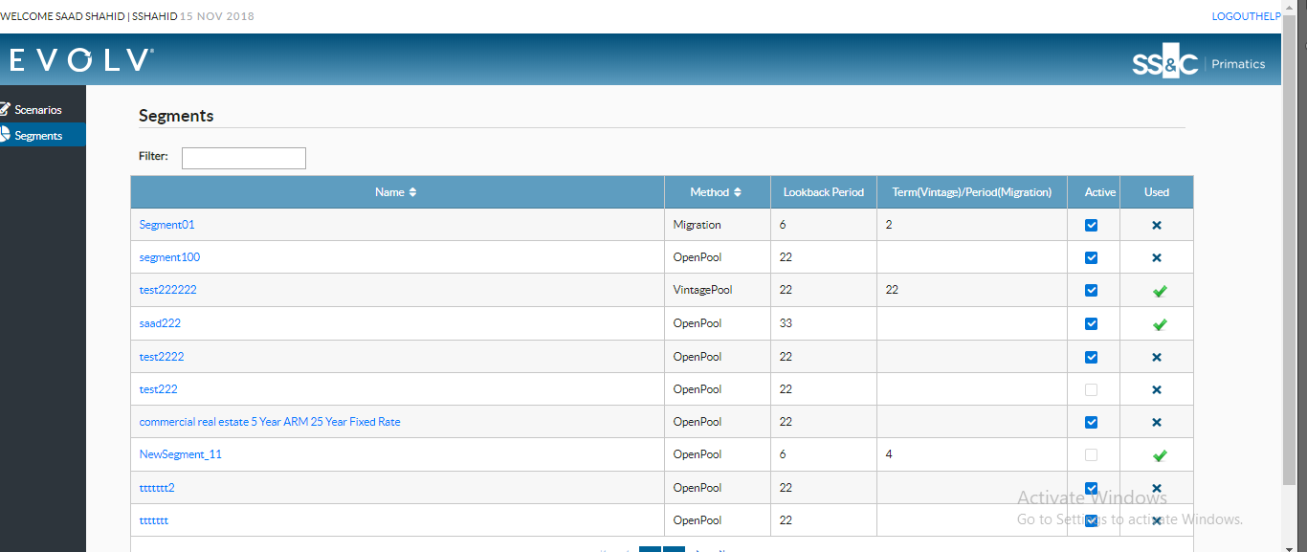

## Activate/Deactivate Segment

User can activate/deactivate segment through checkbox in segment list view and detail view. Deactivated segments are not visible on scenario detail screen.

## Delete segments

Segments can be deleted only if they are not used in scenario execution. If segments are already used in run, (locked action) is shown in USED columns. Segments which can be deleted are indicated through (delete action) sign. On clicking delete option. User is prompted for confirmation.

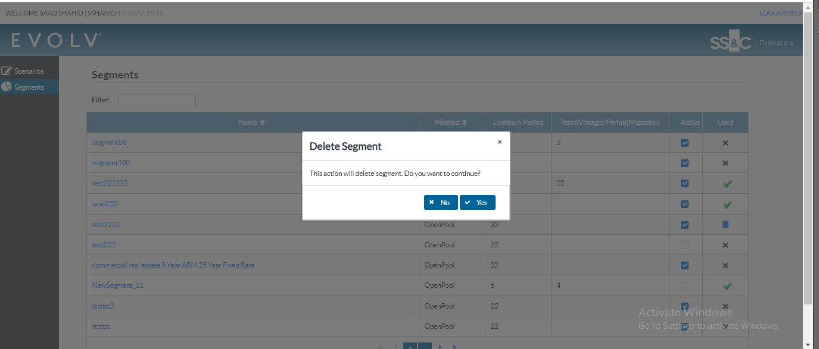

On confirmation, segment is deleted from the screen.

## Edit segments

Segment can be edited by clicking segment name from segment list screen. On clicking segment name and if segment hasn’t been used in scenario run before, following screen will be shown to user.

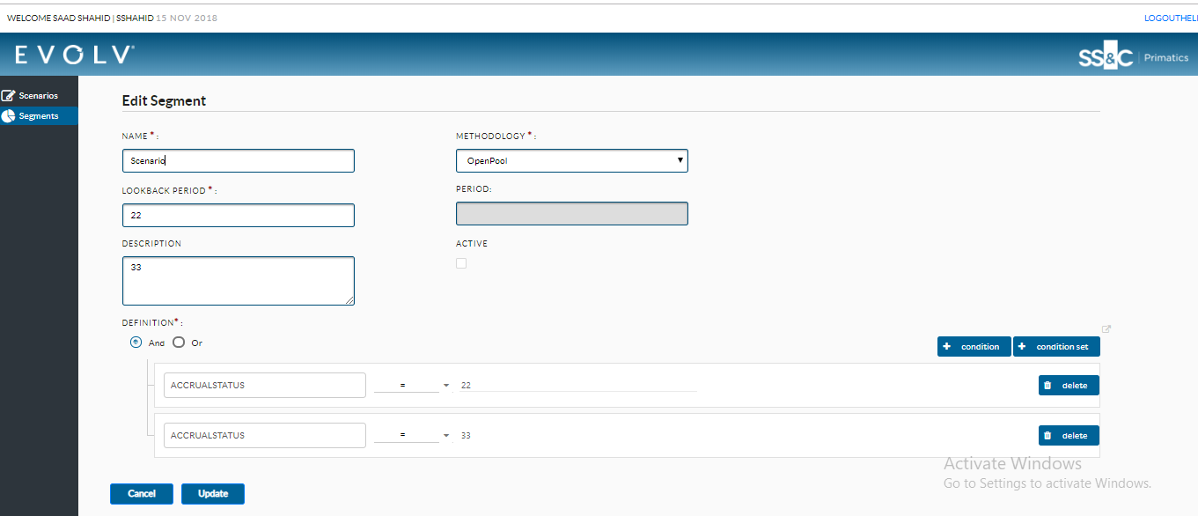

## View Segment

If segment is already in used, user will be shown by following screen. Screen is non-editable and user can view details of segments.

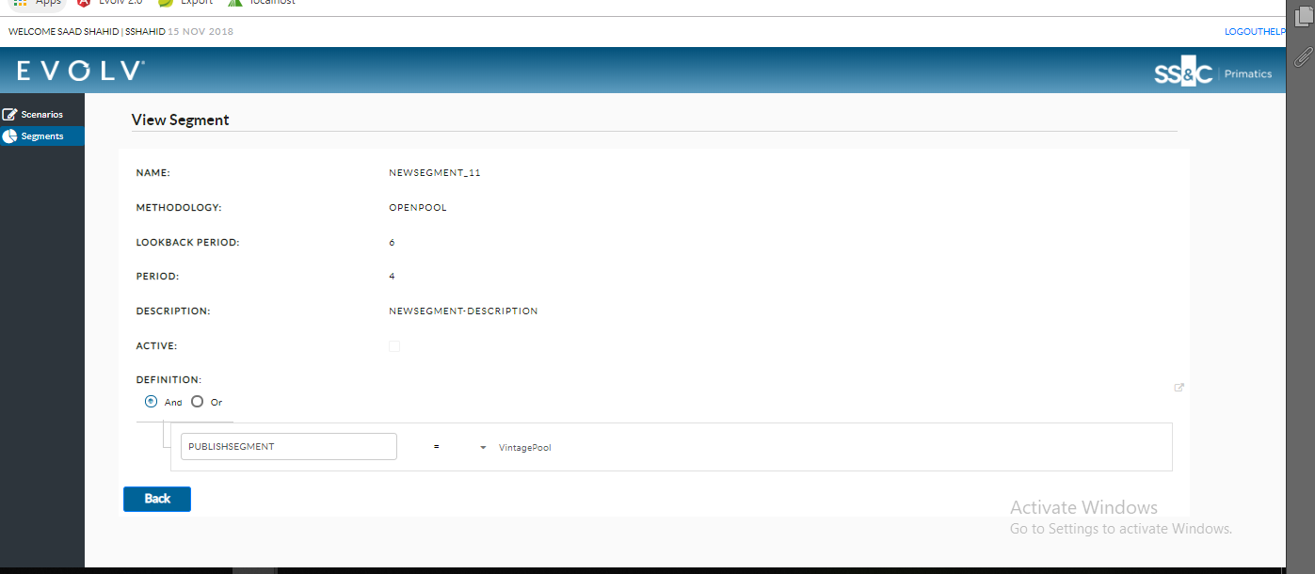

# Baseline loss Rate Scenario Setup

## Scenario List

On pressing scenario list, user will be redirected to following screen.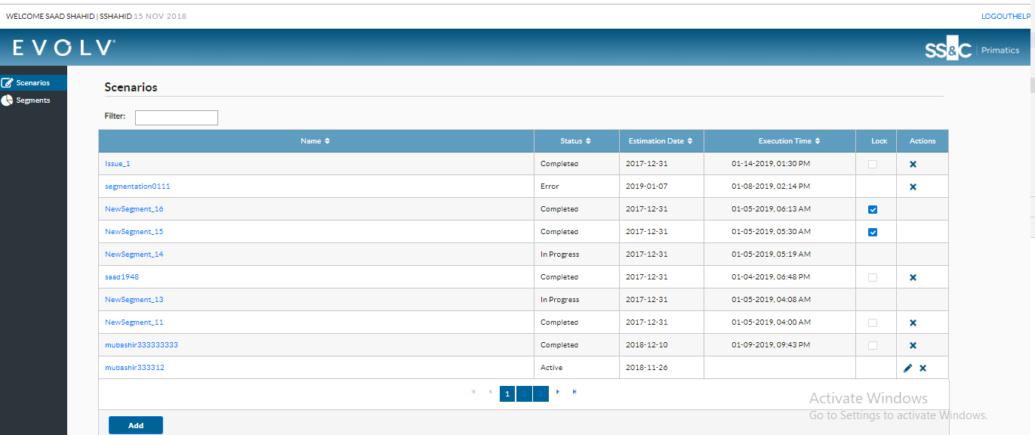

User can add new scenario by pressing add button present at the bottom of the screen.

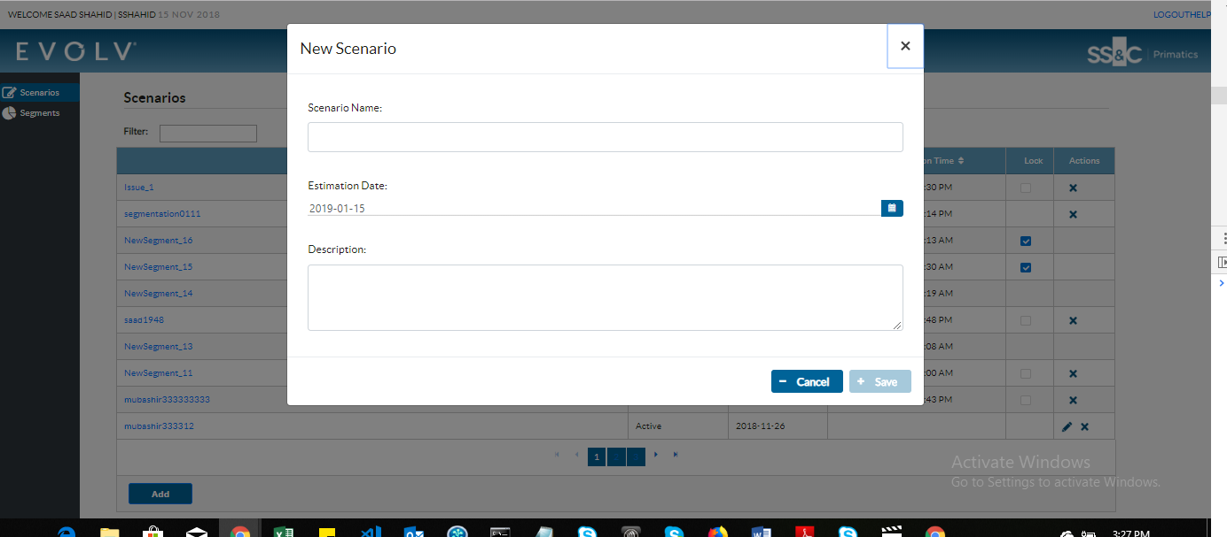

On providing all the mandatory option from the screen, user will be allowed to save scenario. Screenshot is attached for reference

## Add Scenario

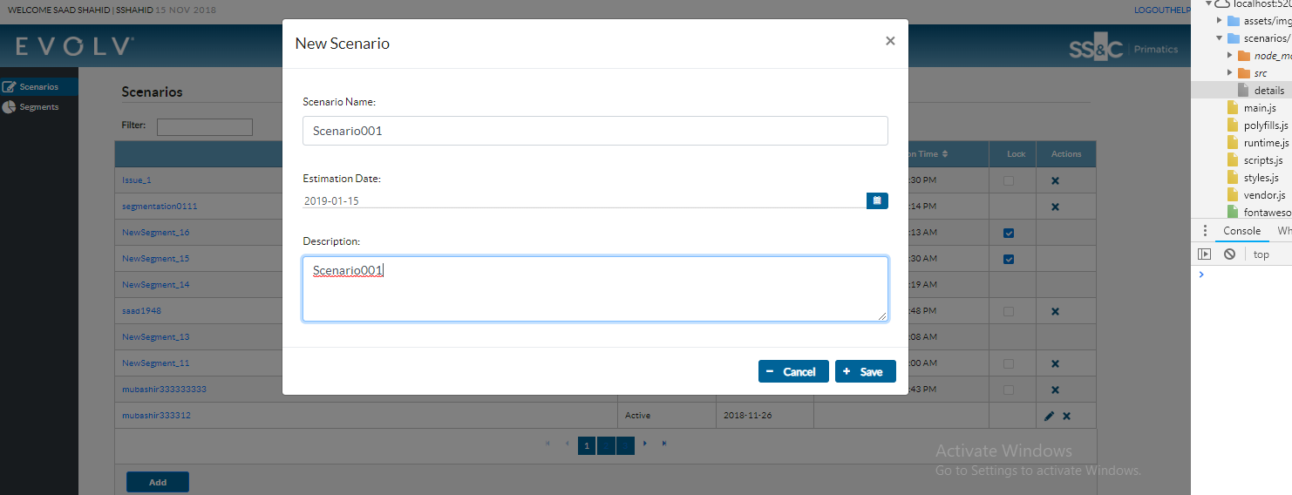

On saving new scenario, record is reflected on scenario list view as following.

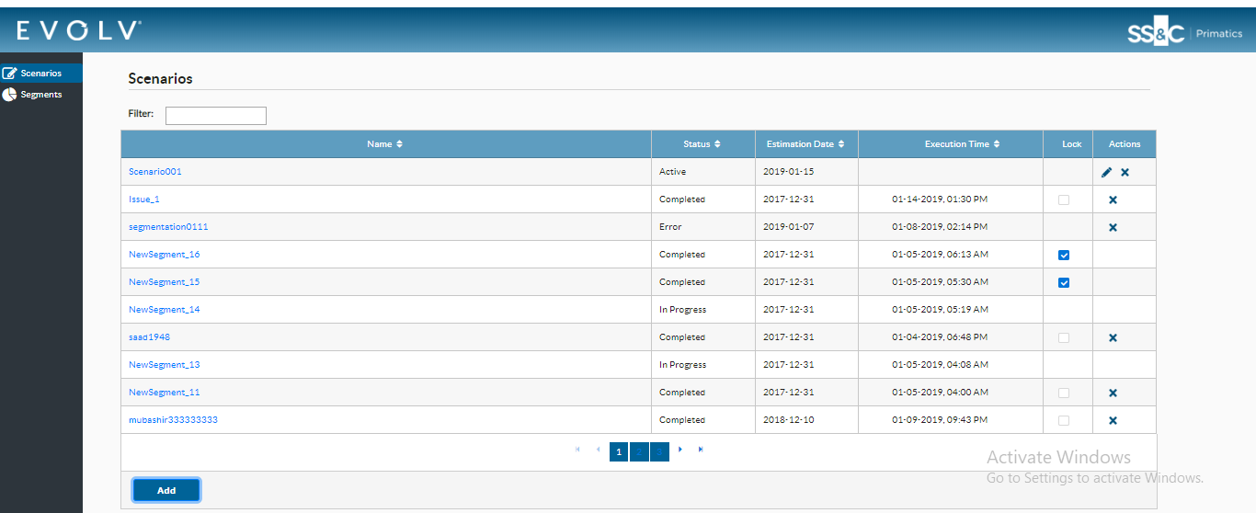

## Edit Scenario

Scenario can be edited by pressing edit action present against scenario name of scenario list. On pressing edit button, user will be shown with following dialog box.

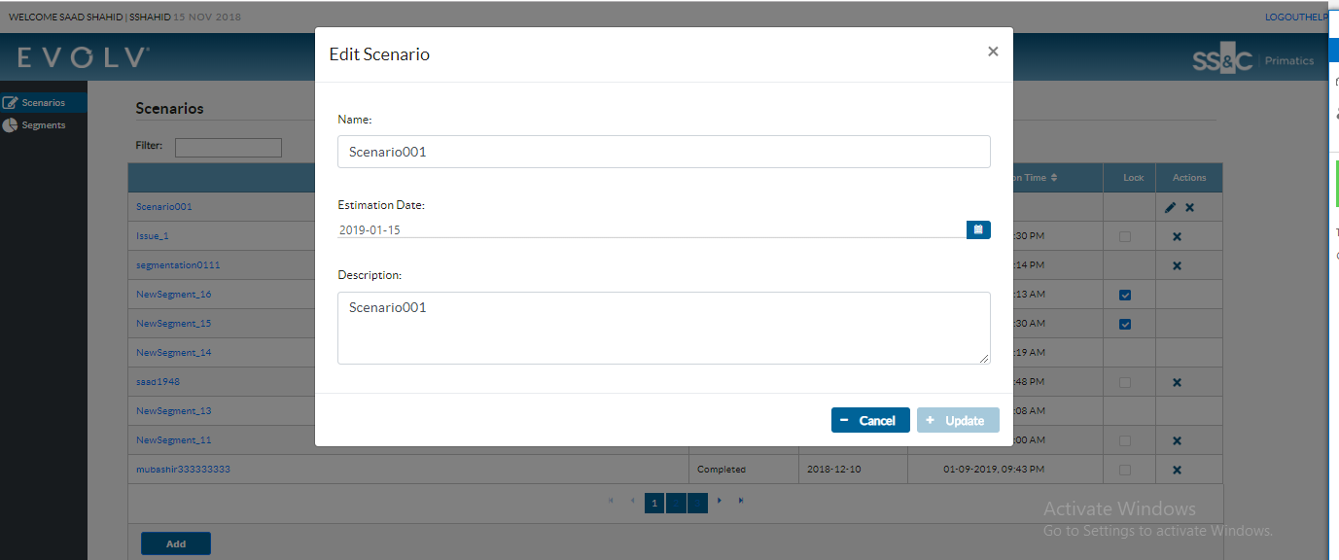

On changing any value from the screen, button at the bottom will be enabled after applying appropriate validation.

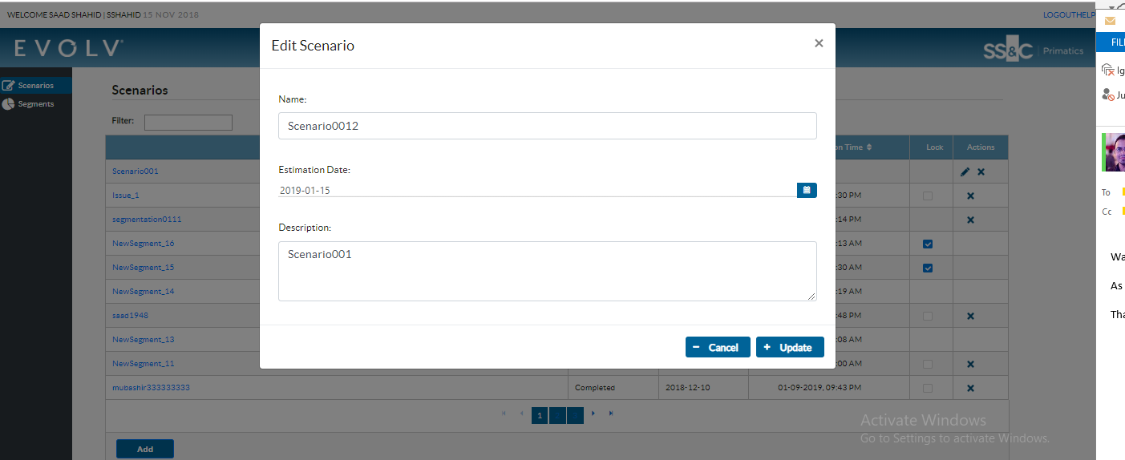

On pressing update button on the screen record will be save and reflected on scenario list screen.

## Delete Scenario

Record can be deleted from the screen by pressing delete action present on the screen. On pressing delete action user will be given following popup message.

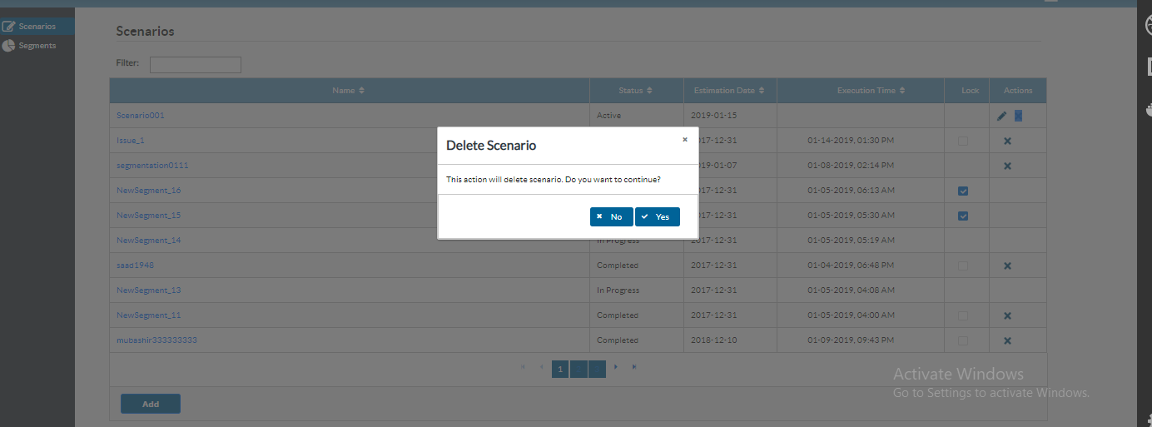

## Lock/Unlock Scenario

Scenario can be lock/unlock by pressing check-box present in scenario list screen. In future, lock button will only be present for the user who have appropriate permission. Right now anyone can lock/unlock scenario.

## View Active Scenario

Newly created scenario are in active state. On clicking active scenario name, user is redirected to scenario detail screen. Scenario detail screen initially will contain all the segments that are active. Screenshot is shown as below.

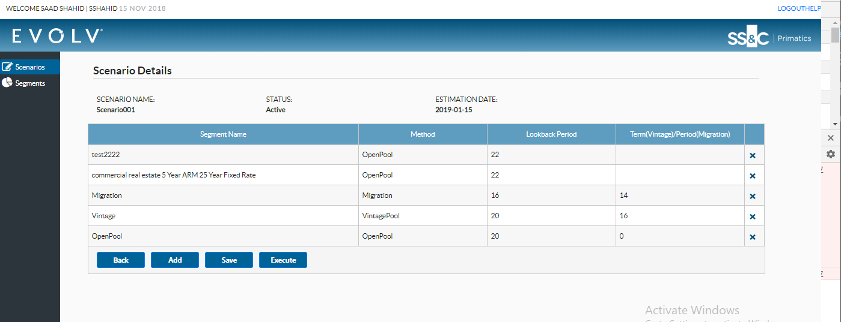

## Save Active Scenario

User can make changes in segments and add/remove segment from screen. After making changes on screen and saving segment, record will be store on schema. On re-opening the screen user will only able to see those segments which are already save. Status of the scenario will remain the same. Screenshot is shown below for reference.

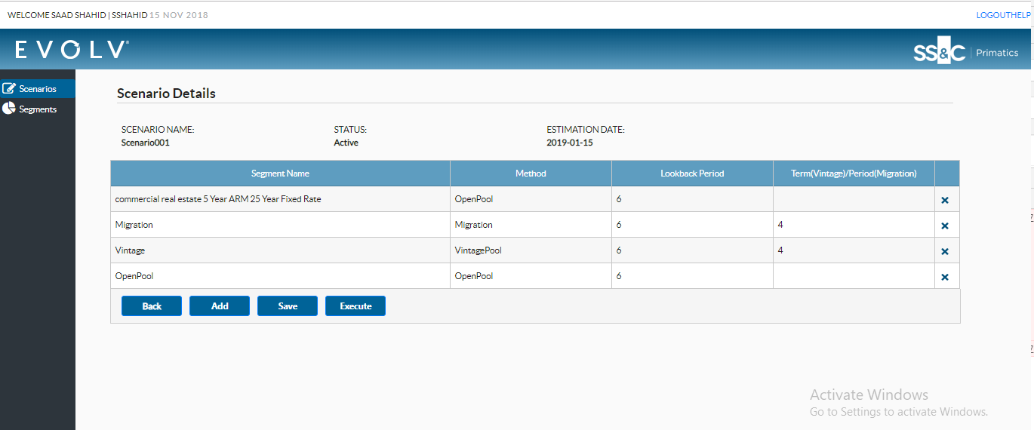

## Execute Active Scenario

Scenario can be executed from execute button present on the bottom of the screen. On pressing execute button, scenario run status changes to in progress. Screenshot is shown for reference.

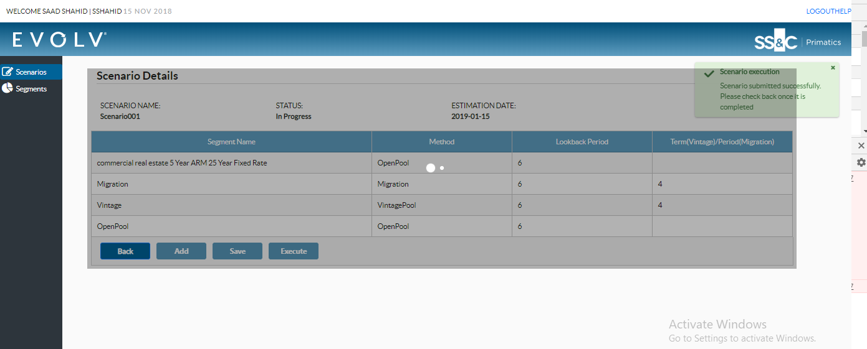

## Error Scenario

If run execution failed due to some reason, screen will become read only and looks as following.

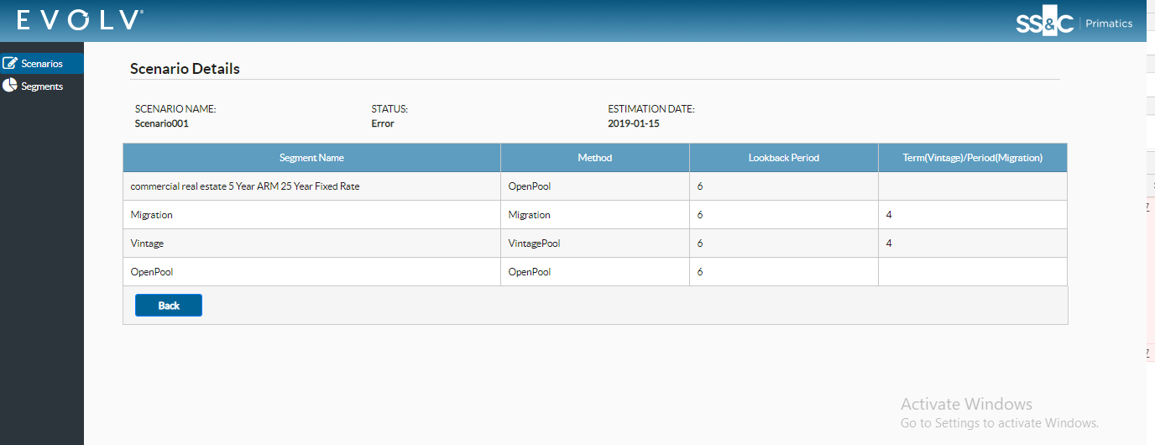

## Complete Scenario

If scenario execution completed successfully, user is redirected to completed screen. Screen look as following.

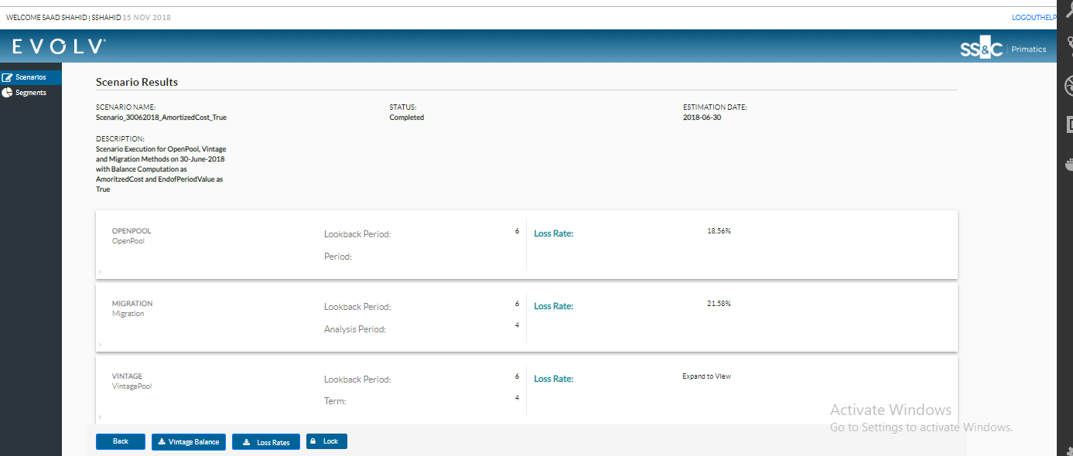

# Baseline loss Rate Scenario Result

Scenario result screen shows intermediate output of vintage, openpool and migration methodology used in run. Detail of scenario results are shown below.

## OpenPool Methodology

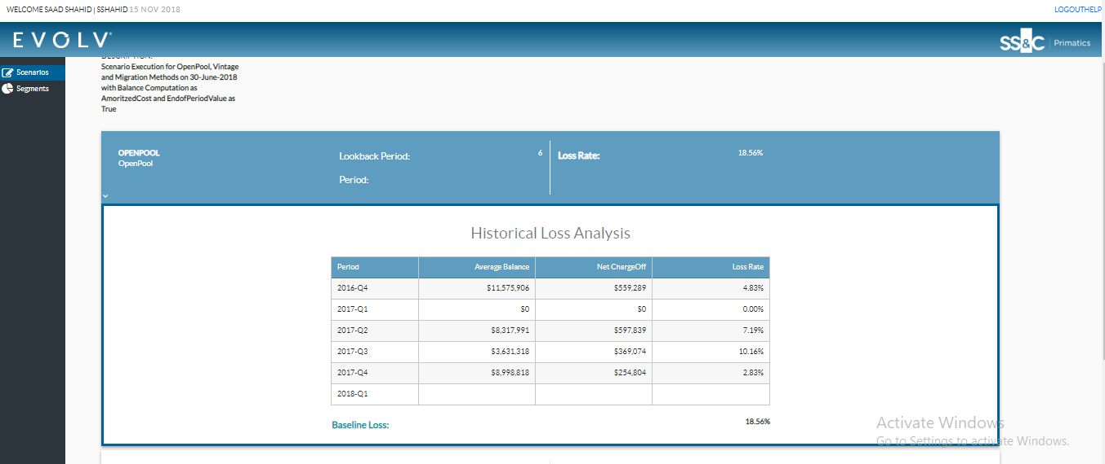

## Migration Methodology

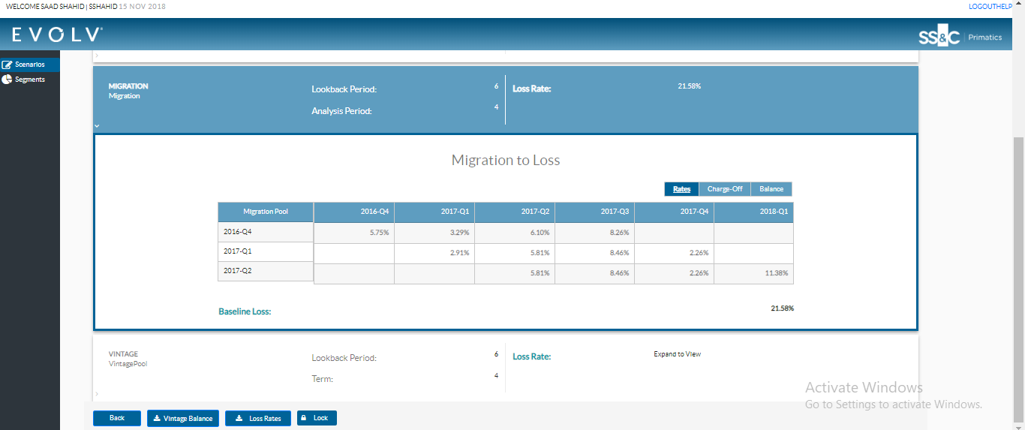

## Vintage Methodology

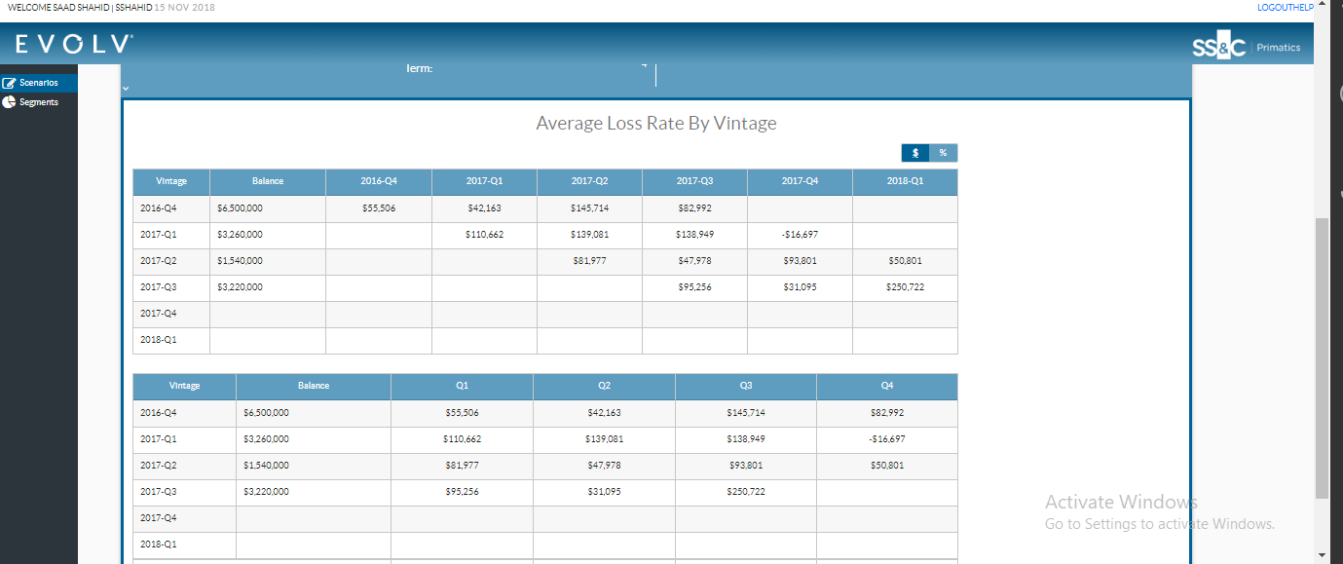

## Download vintage balance

If scenario run uses vintage methodology, button will appear on screen. On pressing the button, file will be downloaded containing vintage balance

## Download loss rate

On pressing loss rate button, file will be downloaded that contains all loss rate.

## Lock/Unlock Scenario

Scenario can be lock/unlock from screen similar to scenario list view screen. In future, lock button will only be present for the user who have appropriate permission. Right now anyone can lock/unlock scenario

# Baseline Loss Rate end-point details

Attach is the file containing all the end-point detail mention on the screen.

